To illustrate SEBAL concept for the Chapter, I’d like to recreate Bastiannsseen’s figure 5 (see below), and add a hypothetical “Wet pixel” and “Dry pixel”.

  This would require entering approximate values of the 5 points on the chart below into Excel and re-creating the chart, then add large circular dots at dT=0 and Tmax.  You could either pick the values off by eye or use datathief (<http://www.datathief.org/>).

 We need to recreate the figure instead of copying it because of the labelling and very small dots they used, and to be consistent with the variables in the text.

  Can you do the figure re-creation, and add dry and wet pixels?  No need to include the regression values or R2, but do include label letters and put the veg types in the caption.  Use the same variable names as we use in the text (eg. To-Ta instead of delT, and TR instead of To).

  At the dry and wet pixels, add the labels:

    Wet pixel

    lambdaET = Rn-G

    H =0

   Dry pixel

   LambdaET = 0

   H=Rn-G

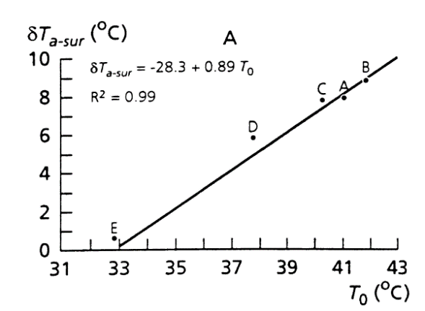



Ok, let me know if you have questions, and thanks in advance.  This way I can keep plugging away at the text in the hour I have to work before the kids get up...!

Bastiaanssen Original:

Figure 1 Linearity of air temperature Ta, near-surface vertical air temperature differences in δTa, and surface temperature T0 measured at the West Central Super-site during HAPEX-SAHEL, September 1992, Part A: δTa(T0) relationship, Part B: Ta(T0) relationship

Altered for book chapter:

Figure 2 Linearity of Near-surface vertical air temperature differences in T0-Ta, and surface temperature T0 measured at the West Central Super-site during HAPEX-SAHEL, September 1992. Wet and Dry refer to wet and dry pixels selected in the image.

Questions:

*Use the same variable names as we use in the text (eg. To-Ta instead of delT, and TR instead of To).*….so would that mean use TR-Ta instead of delT?